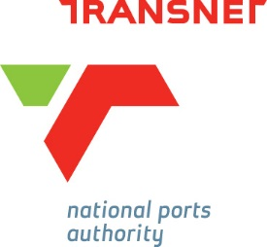
TRANSNET SOC LIMITED
(Reg. No. 1990/000900/30)
Trading through its operating division

Transnet National Ports Authority

Addendum No. 01

POD 12/2024/RFP - FOR LEASE APPLICATION ADVERT IN THE PORT OF DURBAN

Prepared by:
Nonhlanhla Mndebele – Property Manager

POD 12/2024/RFP - FOR LEASE APPLICATION ADVERT IN THE PORT OF DURBAN

Tenderers are to note the following amendments to the tender documentation. All other tender documentation remains unchanged

ADDENDUM NO.1

THE FOLLOWING HAS BEEN AMENDED:

- NON-COMPULSORY BRIEFING SESSION

- Please note that bidders must visit the site/premises and be aware of the condition of the site/premises.
- Bidders are advised to sign the provided slip as proof of visiting the site and indicate the beneficial occupation period the bidder might require with motivation.

All other terms and conditions remain unchanged.

All tenderers are hereby requested to sign this addendum as an acknowledgement and consent to this addendum and return as a returnable together with their proposal documents.
The undersigned confirm that the following communications received from the employer before the submission of this tender offer, amending the tender documents, have been taken into account in this tender offer.

Received by:
Date

